**Title (Times New Roman Bold 14 pt)**

First Author1, Second Author2 and Other Authors3,* (Times New Roman 11 pt)

*1 Affiliation and full address of the first author (Times New Roman Italic 10 pt)*

*\* Corresponding author: info@dbar2025.com*

Main text.

(Page Limit: The abstract length should be limited to 1 to 3 pages and font size 12 Times New Roman)

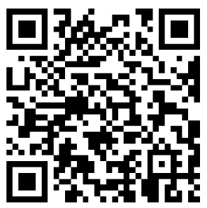

**Fig.1.** Please elaborate on the image.

**Key Words:** Abstract, Abstract, Abstract **(limited to 3-5 words)**