**Title：Abstract Template and Instructions for Authors**

XXX 1*

1*Institute of Mountain Hazards and Environment, Chinese Academy of Sciences,* Sichuan *610000, PR China*

*\*Corresponding author: Email address*

**Abstract**

The SNCC2024 welcomes original research and review papers concentrated on conference topics. The abstract must convey the main content of the paper, as it will be helpful for selecting the conference oral presentations. The length of abstract should be no more than 800 words, and may include figures.

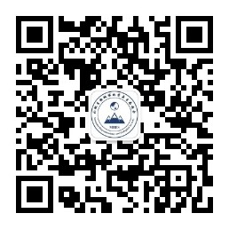

**Figure 1**. Institute of Mountain Hazards and Environment, Chinese Academy of Sciences [1]

The abstract should be submitted via the conference submission system. The author will be required to register at the website and make the submission following the instructions.

The abstract submission deadline is: **April 17, 2024**.

**Keywords:**3-6 keywords, separated by commas