Title of the Manuscript
(14-point, bold, centered, capitalize the first letter of the initial word)
A. Author¹ B. Author² and C. Author^{3*}
(Authors’ full names, e.g. 12- point, centered, use superscripts in numbers to indicate affiliation)
¹Department, University, City, Postal code, Country
²Corporation or Laboratory, Street address, City, Postal code, Country
Correspondence: Full name (Email address)

Abstract: Authors presenting papers to ICBE 2022 conference should use this template to prepare the manuscript as it contains all necessary formats and styles. A concise and factual abstract is required, which should concisely state the purpose of the research, the principal results and the major conclusions. Be sure to adhere to the word limitation for the abstract (500 words) and keep font styles and sizes consistent.

Keywords: list up to 3-6 items, use proper capitalized proper nouns and acronyms only

1 Introduction (12- point, bold, capitalize the first letter of the initial word only)
The manuscript must be submitted via the ICBE 2022 submission system as an attachment. The suggested length of the manuscript should not exceed 5,000 words and 10 illustrations.

1.1 Subheadings (12- point, bold, capitalize the first letter of the initial wordonly, double space)
1.2 ….

2 Materials and method (12- point, bold, CAP. first letter of the first word)
2.1 Subheadings (12- point, bold, CAP. only first letter of first word)
2.1.1 Sub-Subheadings (12-point, bold, CAP. only first letter of first word, double space)
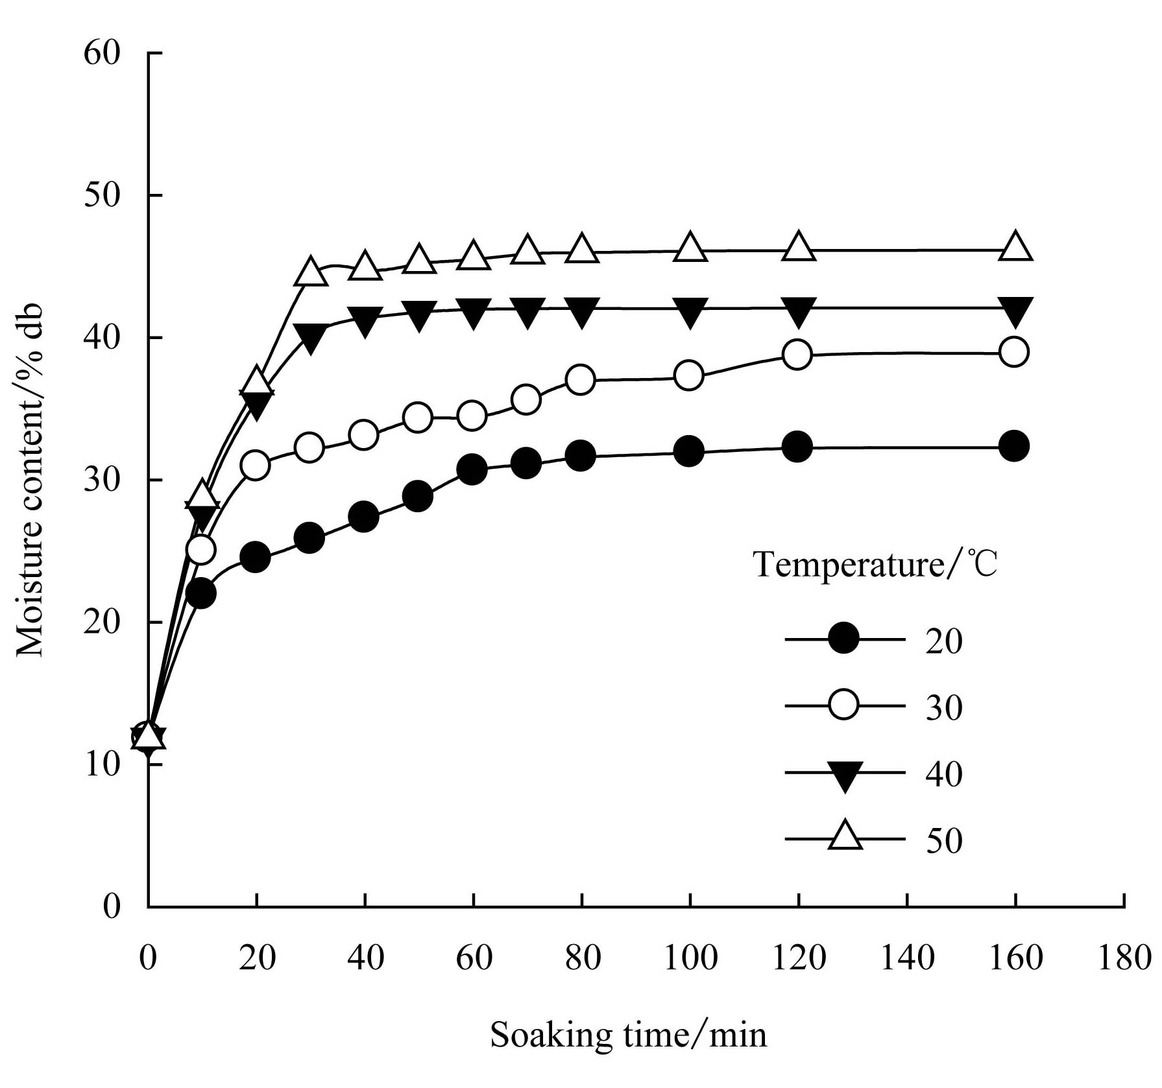
Figure XX
(Caption lower case except for the first letter, 12- point, not bold, centered below figure, figures should appear after they are previously mentioned in the text)
Table XX Parameters of the experimental program
Parameters | Values
Material | wilted grass, first and second cut
DM/% | 20 - 50
lC/mm | 4, 9, 11, 17
P_{max}/kPa | 50, 100, 200, 400
f/Hz | 0, 5, 29
Compaction duration/s | 0.5
Time without compaction/s | 2.5
Number of compaction cycles | 6 (corresponds to the number of passes)
Note: DM means dry mass; lC means theoretical cutting length; P_{max} means compaction pressure; f means frequency.

(Caption lower case except for the first letter, 12- point, bold, centered above table, tables should appear after they are previously mentioned in the text)

(Equations that are referred to in the text are identified by parenthetical numbers, such as (1), and are referred to in the manuscript as "equation (1)". Use Word built-in equation editing tool or other equation-editing software such as Math Type to edit equations. )
$P_{m}=\frac{P_{p }+P_{b}}{2}$ (1)
where, $P_{m}$ is mean pressing pressure in the material, kPa; $P_{p }$ is pressing pressure at the piston, kPa; $P_{p}$is pressing pressure at the cylinder base, kPa.

3. Results and discussion

4. Conclusions

Acknowledgements: Individuals or group other than the authors who were direct help in the work should be acknowledged. Information on research grants should be mentioned here.

References: All references should be numbered in Arabic numerals according to their sequence in the text and bracketed, e.g. [1], [2, 3] and [4-7] as superscripts. Personal communications and unpublished data are not acceptable as references. Different kinds of references should be referred to as follows.

• Papers in periodicals should be referred in the order: name of author(s), title of paper, name of periodical (in italic), year, Volume (in bold), and pages. For example:
[1] Vincent J F V. Dynamics of drying in phenolically tanned materials. Journal of Bionic Engineering, 2004, 1(1):4−8.
• Books should be referred to in the order: name of author(s), title of books (in italic), publishing house, city, country, year, and pages. For example:
[2] Ren L Q. Optimum Design and Analysis of Experiments, 2nd ed, Higher Education Press, Beijing, China, 2003: 20-50.
• Papers in conference proceedings should be referred to in the order: name of author(s), title of paper, name of conference(initalic), city, country, year, and pages. For example:
[3] Ren L Q, Tong J, Li J Q, Chen B C. Soil adhesion and biomimetics of soil-engaging components in anti-adhesion against soil: A review. Proceedings of the 13th International Conference of ISTVS, Munich, Germany, 1999, 233−240.
• Website online publication should be referred in the order: name of author(s) (if available), title of paper or web page, [date], and website address. For example:
[4] Stockman A. Color & Vision Database, [2005-04-05], http://cvision.ucsd.edu

