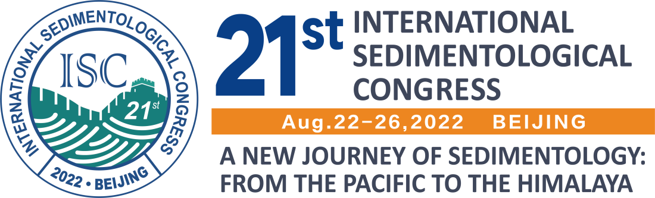

Certificate Of Attendance

This is to certify that registered and attended the 21st International Sedimentological
Congress (ISC2022)

Paper:

Thanks for your contribution to the success of the 21st ISC.

Organizer: | The China University of Geosciences (Beijing)
Co-organizer: | China National Petroleum Corporation (CNPC), China National Offshore Oil Corporation (CNOOC), China Petroleum & Chemical Corporation (SINOPEC), Chinese Association of Sedimentologists (CAS), and National Natural Science Foundation of China (NSFC)
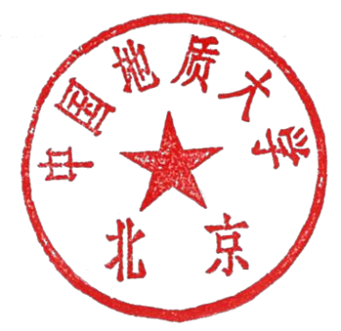

The Organizing Committee of The ISC 2022

