Record audio in Keynote on Mac
You can record audio as a voiceover narrative or soundtrack for an individual slide or for your entire presentation. A voiceover narration is a synchronized recording of yourself talking about each slide, which is especially useful when your presentation plays unattended in a kiosk setting.

Record a oviceover narration
To record a voiceover narration, you advance through the presentation at your natural speed as you talk. As you advance through each slide or build, your voice and timing are recorded and preserved for playback.
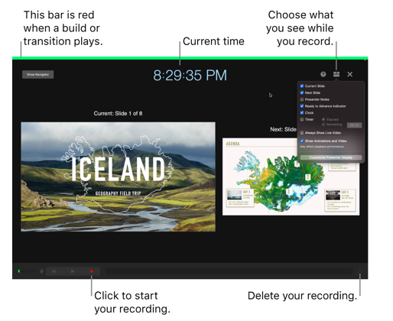
1.Click to select the slide where you want the recording to start.
2.Click in the toolbar, then click the Audio tab at the top of the sidebar on the right.

3.Click Record in the sidebar.The recording window appears.
4.To start recording your presentation, click at the bottom of the window.The timer counts down from 3 before recording begins.
5.Speak clearly into the microphone to begin your narration.
6.To advance to the next slide, click the slide in the recording window, or press the Right Arrow key on your keyboard.
You can pause the recording at any time by clicking the Pause button. Click to resume recording.
7.To stop recording, click .
8.Press Esc to save the recording and exit the presentation.
To listen to your narration, play your slides.

Add video and audio in Keynote on Mac
You can add video and audio to a slide, or replace a media placeholder with a video. When you show the slide during a presentation, by default the video and audio plays when you click. You can set video or audio looping, or set the start time to make the media files play automatically when the slide appears. You can also add a soundtrack that plays for the entire presentation.
Note: Video and audio files must be in a format that QuickTime supports on your Mac. If you can’t add or play a video or audio file, try using iMovie, QuickTime Player, or Compressor to convert the file to a QuickTime file (with a .mov filename extension) for video, or an MPEG-4 file (with a .m4a filename extension) for audio.
You can also record audio and add it to your presentation.

Add video or audio
When you add a video or audio file to a slide, the video or audio plays only when that slide is showing in your presentation.
Do one of the following:
- Drag a media file from your computer to a media placeholder or anywhere else on the slide.
- Click in the toolbar, click Movies or Music, then drag a file to a media placeholder or anywhere else on the slide.

Tip: To search for a music file, click the magnifying glass in the upper-right corner of the media window.
Click the Play button on the media to play it.

Add a video from a web
You can add links from YouTube and Vimeo so videos play right in your presentation.
Important: This feature may not be available in all regions.
1.Click in the toolbar, then click Web Video.
2.Type or paste a link to the video, then click Insert.
3.To play the web video in your presentation, click the Play button .
Note: You must be connected to the internet to play a video from the web.
When you play your presentation, web videos play in front of overlapping objects on the slide.
When you paste supported video links into your presentation, they are inserted as web videos by default. To change this preference, choose Keynote > Preferences (from the Keynote menu at the top of your screen), then deselect the checkbox next to “Paste YouTube and Vimeo links as web videos.”

