How to record the screen on your Mac
You can use Screenshot or QuickTime player to make a video recording of the entire screen or just a selected portion of it.

Use the Screenshot toolbar
To view the Screenshot toolbar, press these three keys together: Shift, Command, and 5. You will see onscreen controls for recording the entire screen, recording a selected portion of the screen, or capturing a still image of your screen:
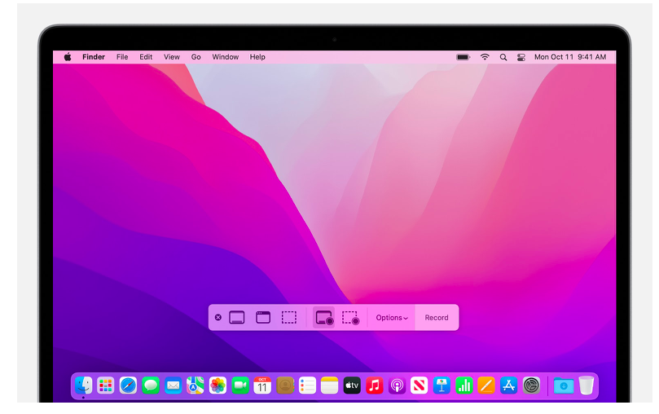

Use QuickTime Player
1.Open QuickTime Player from your Applications folder, then choose File > New Screen Recording from the menu bar. You will then see either the onscreen controls described above or the Screen Recording window described below.
2.Before starting your recording, you can click the arrow next to the Record button to change the recording settings:
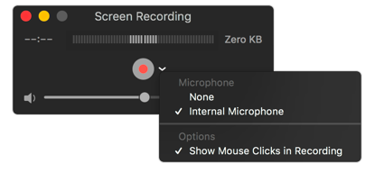

- To record your voice or other audio with the screen recording, choose a microphone. To monitor that audio during recording, adjust the volume slider. If you get audio feedback, lower the volume or use headphones with a microphone.
- To show a black circle around your pointer when you click, choose Show Mouse Clicks in Recording.
3.To start recording, click the Record button and then take one of these actions:
- Click anywhere on the screen to begin recording the entire screen.
- Or drag to select an area to record, then click Start Recording within that area.
4.To stop recording, click the Stop button in the menu bar, or press Command-Control-Esc (Escape).
5.After you stop recording, QuickTime Player automatically opens the recording. You can now play, edit, or share the recording.

