ZOOM video recording guide
- Enter the download address in the browser and download the software package. Windows software download address: http://www.zoomus.cn/support/download/
Apple (MAC) software download address: https://www.zoomvideo.cn/download/

- Log in to the zoom account (if you don't have an account, you can register in official website for free), and click on the logo in the upper right corner of the
page to set it.
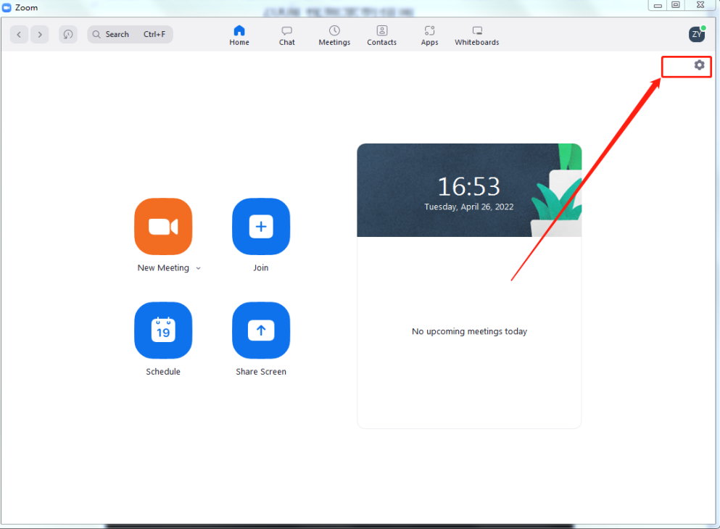

3.Select the [Record] option on the left menu to make relevant settings.
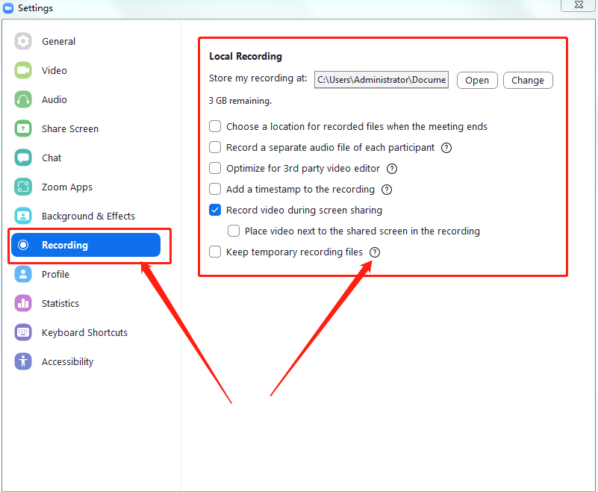

4.After the setup is completed, create a new conference room.

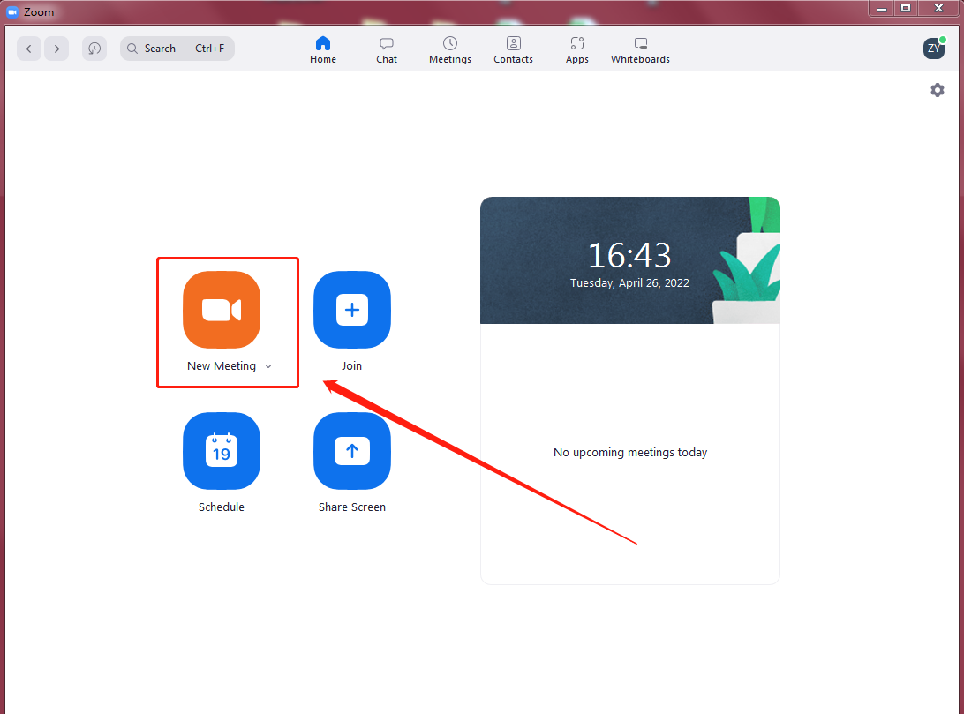

- After creating the conference room, click Record, click Share screen, and then
open the PPT of the speech.
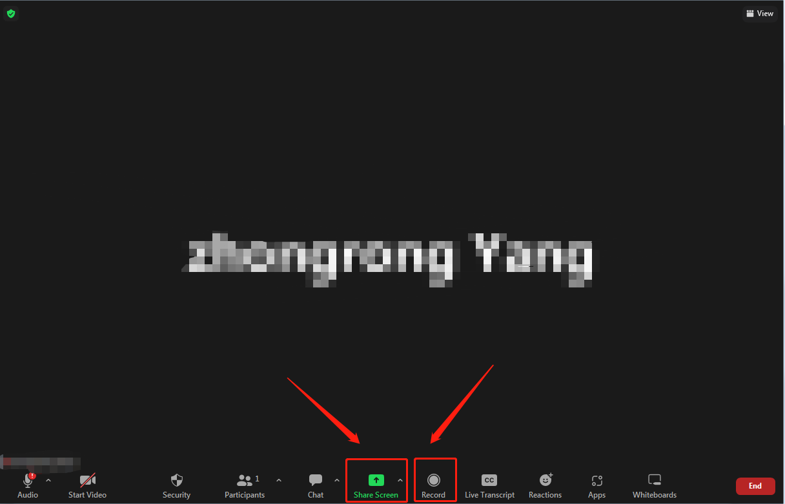
‘

6.After the speech, click Stop Recording and leave the conference room.

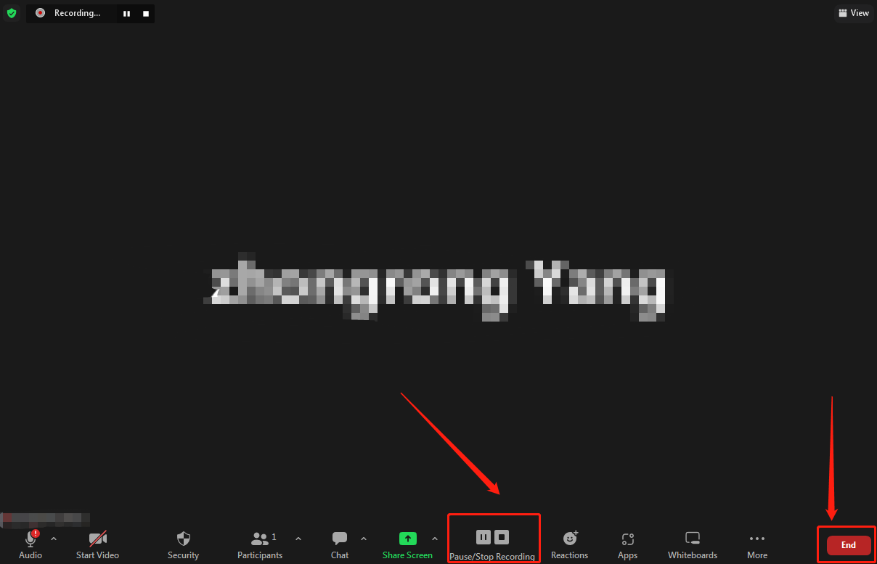

7.After leaving the conference room, ZOOM will automatically save the recorded video as MP4.

