Tencent Conference Video Recording Guide
- Download Tencent Conference from the official website of Tencent Conference.
https://meeting.tencent.com/download-win.html?fromSource=sem81_gwzcw.447781123.4477849.447781162&bd_vid=8066037548538211975
2. Register/Login to Tencent Conference
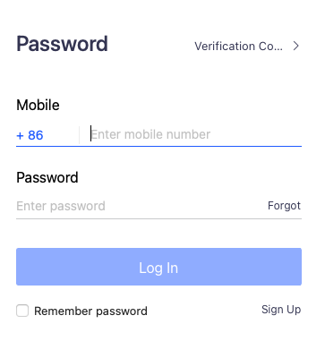
3. Use computer audio.
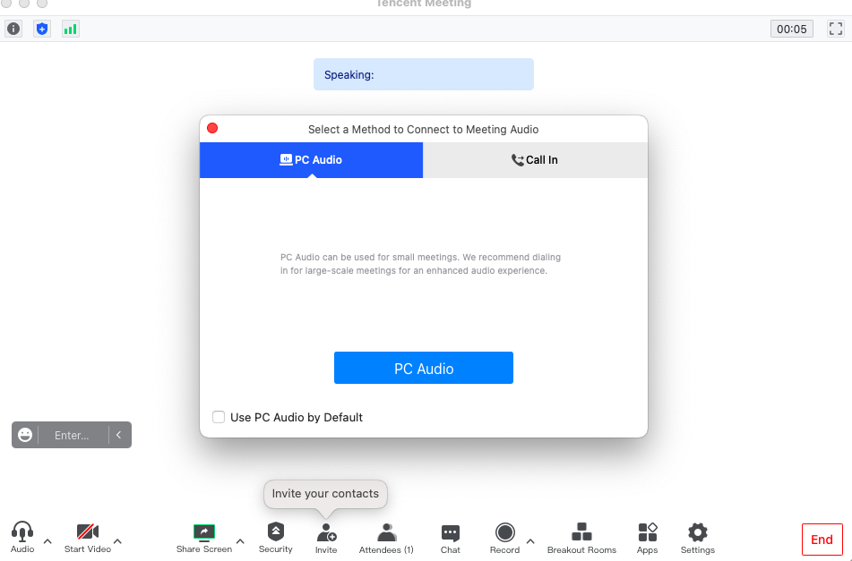

4. Set the video recording storage location and format in advance before recording. It is recommended to store the desktop.
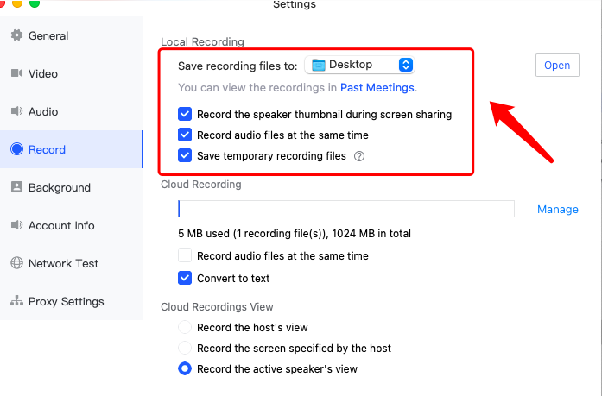5. Click Local Recording.
