**Invitation Letter for China Visa**

Dear Embassy of the People's Republic of China in [ Country ]:

I am writing on behalf of the 1st International Symposium on Soil Nutrient Cycling along Chronosequences and its Implications for Ecological Restoration. We are hosting this conference from May 6 to 11, 2024 in Chengdu, Sichuan Province, China.

We would like to extend our invitation to [Invitee's Full Name], who holds the nationality of [Invitee's Nationality] and is currently working as a/an [Invitee's Occupation]. The details of the invitee are as follows:

- Name: [Invitee's Full Name]

- Passport Number: [Invitee's Passport Number]

- Date of Birth: [Invitee's Date of Birth]

- Occupation: [Invitee's Occupation]

- Expected Dates of Visit: [Invitee's Expected Dates of Visit]

The conference will provide a platform for experts to discuss and exchange ideas on various aspects of Soil Nutrient Cycling along Chronosequences. The venue for this conference is located in the Institute of Mountain Hazards and Environment, CAS at Chengdu, Sichuan, China.

We truly appreciate your assistance in processing the visa application for [Invitee's Full Name].

If you require any further information or documents related to this matter, please feel free to contact us.

Conference E-mail: SNCC2024@outlook.com

Best regards,

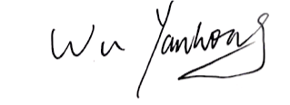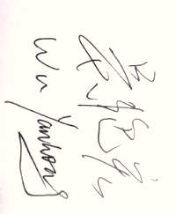

President of SNCC2024

March 6, 2024

Conference Venue: Institute of Mountain Hazards and Environment, Chinese Academy of Sciences

No.189, QunXianNan Street, TianFu New Area, Chengdu, Sichuan P.R. China

Email: SNCC2024@outlook.com

URL: http://sncc2024.huicekeji.com/